Global Laplacian Coordinates Framework
Cotangent weights:
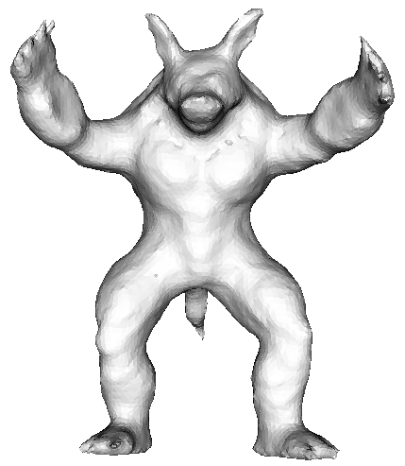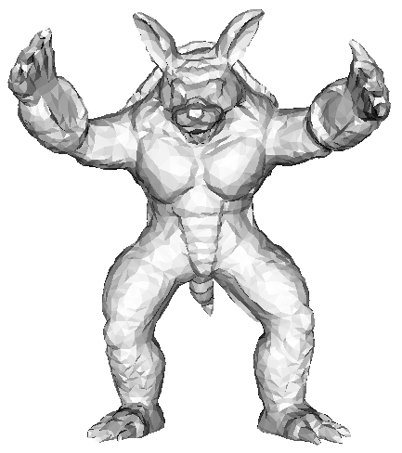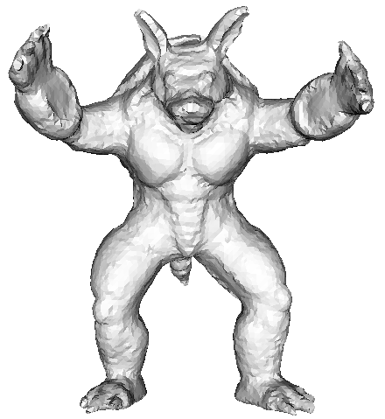
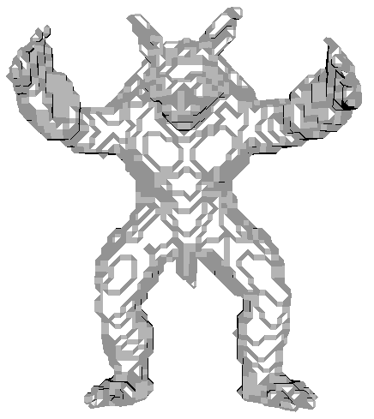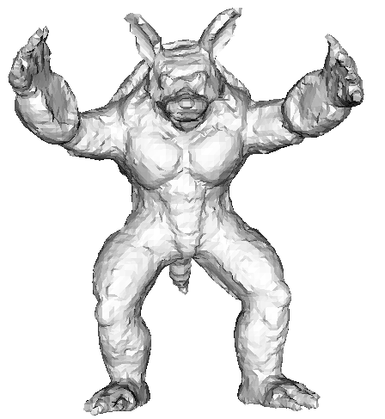
Original mesh the ideal mesh deform result by Laplacian coordinates
 | Max distance | Mean distance
First row | 0.013131 | 0.000564
Second row | 0.010351 | 0.002384
The closest distances from the result mesh to the ideal mesh.
Conclusions:
The correspondences should be improved; maybe we should remove some bad closest point correspondences.

||L*V – L * closestPoints||^2 + ||V - closestPoints||^2

Uniform weights:
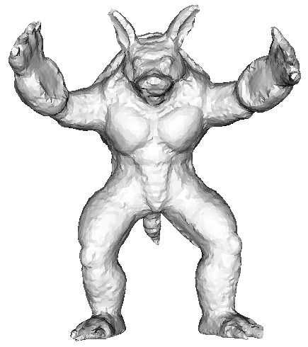
Original mesh the ideal mesh deform result by Laplacian coordinates
 | Max distance | Mean distance
First row | 0.013131 | 0.000560
Second row | 0.010351 | 0.002372
The closest distances from the result mesh to the ideal mesh.

